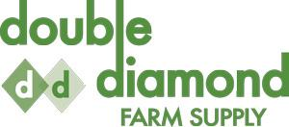

ELGIN SOYBEAN VARIETY TRIAL
DEKALB 22-60 60.6 bu
DEKALB 23-11 61.7 bu
DEKALB 23-60 60.6 bu
DEKALB 24-12 62.3 bu
AKRAS 62.6 bu
P002T04R 50.9 bu

YIELDS ADJUSTED TO 13.5% MOISTURE
